ISTEP/ECA Math Prep
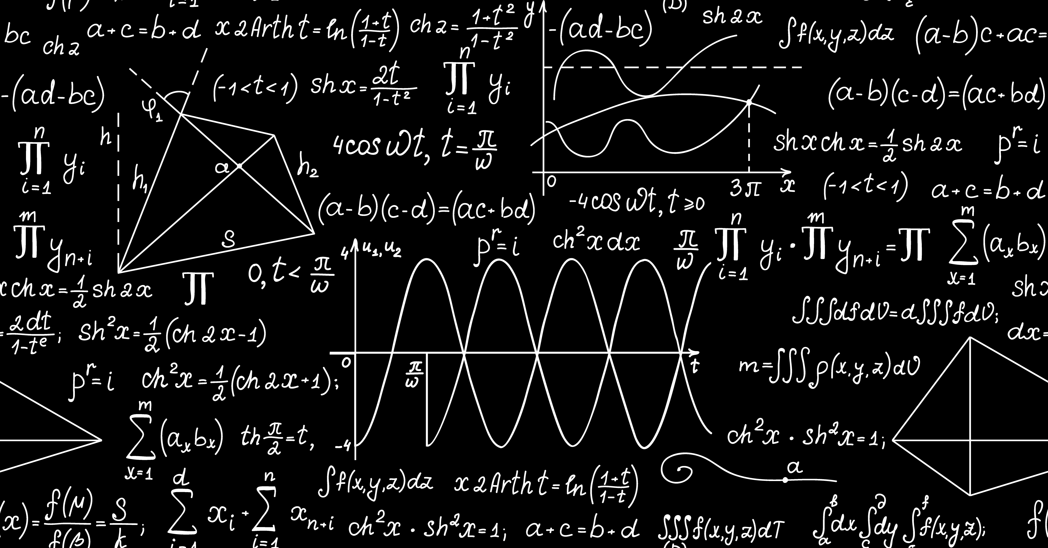

MANIC MONDAYS
With Mr. Newsom in Room 111, Block 5
1:25 p.m. – 2:25 p.m.

THIRSTY THURSDAYS
With Mrs. Czubernat in Room 109, Block 5
1:25 p.m. – 2:25 p.m.

